Assignment 2

1. Write a program to accept percentage from the user and display the grade according to the following

Marks Grade >**90** A >80 and <=90 B >=60 and <=**80** C below **60** D

Code:

grade=int(input("Enter your percentage"))

if grade>90:

print("You got A grade")

elif grade>80 and grade<=90:

print("You got B grade")

elif grade>60 and grade<=80:

print("You got C grade")

elif grade>40 and grade<=60:

print("You got D grade")

else:

print("You are Failed")

Output:

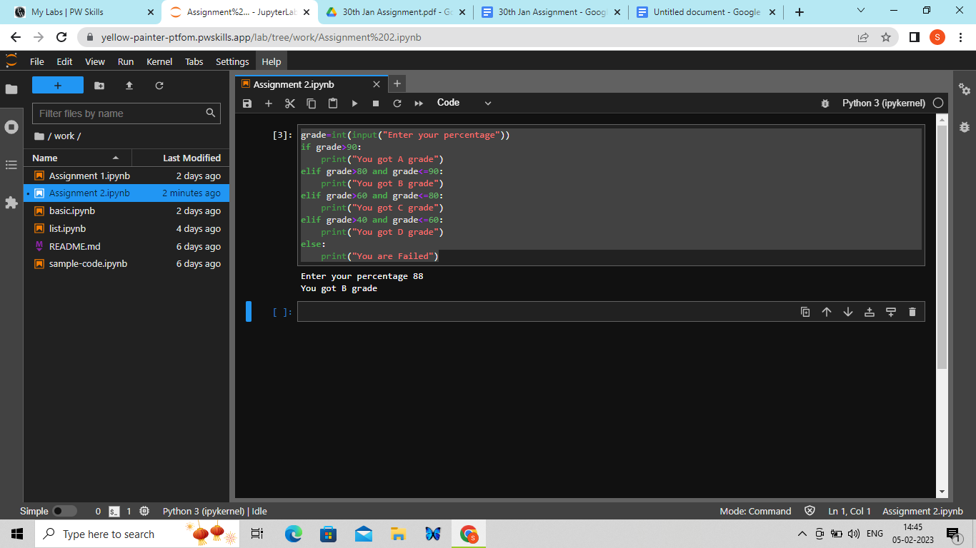

2. **Write** a program to accept the cost price of a bike **and** display the road tax to be paid according to **the**

**following** criteria:

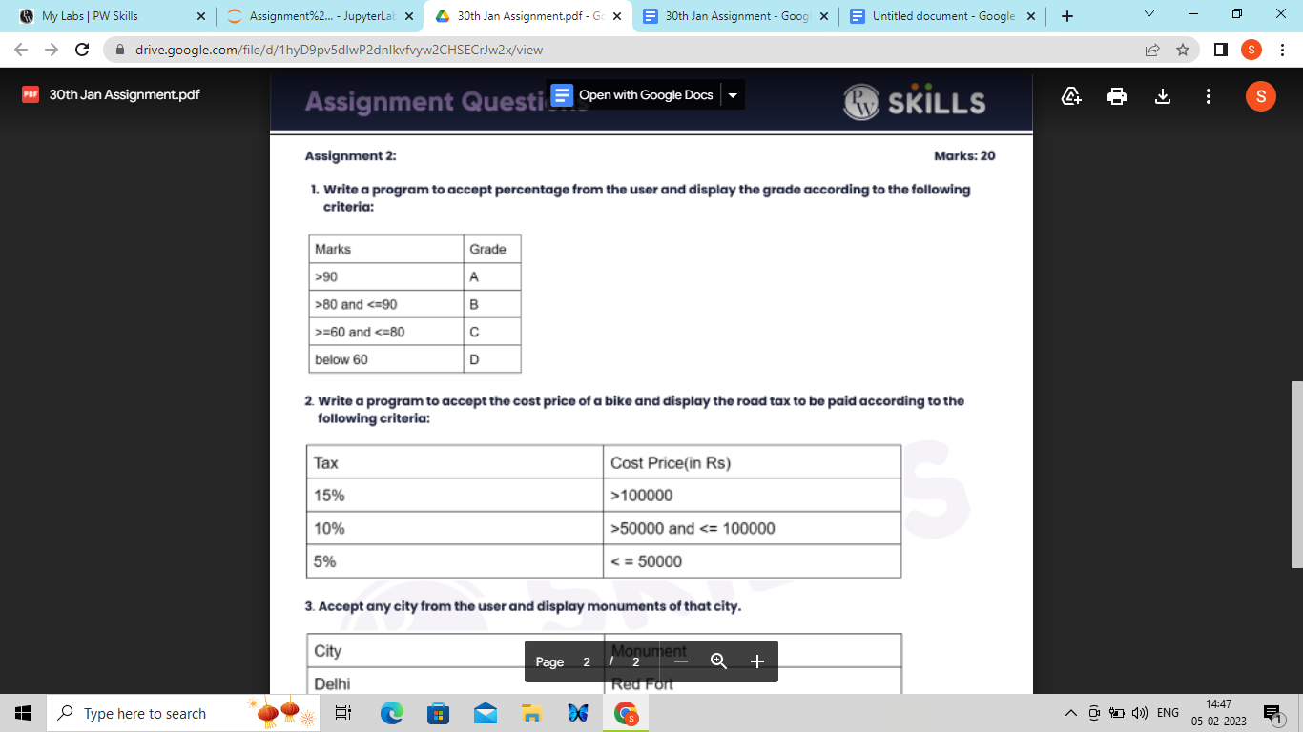

Code: cost=int(input("Enter the cost price of a bike"))

if cost>100000:

print("You have to pay 15% of tax")

elif cost>50000 and cost<=100000:

print("you have to pay 10% of tax")

else:

print("You have to pay 5% of tax")

Output:

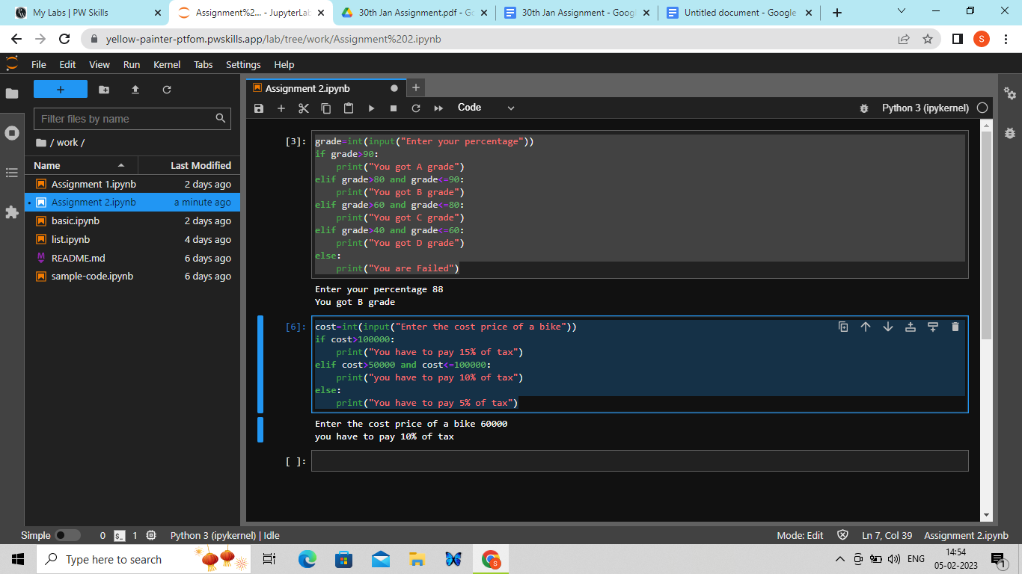

3 Accept any city from the user **and** display monuments of **that** city.

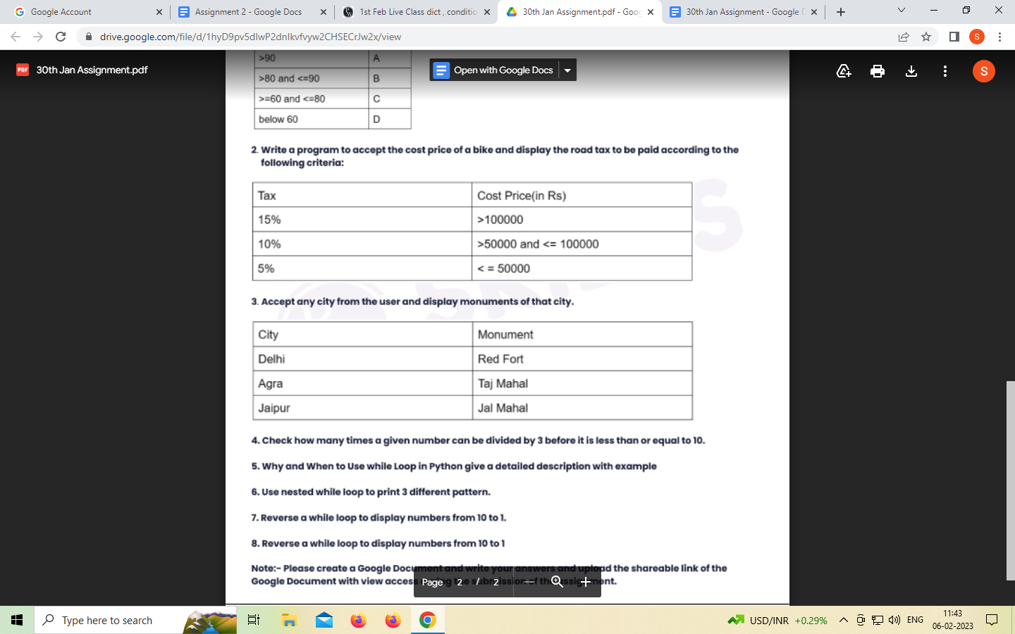

Code:

A='Delhi'

B='Agra'

C='jaipur'

print("Name of the City is : Delhi,Agra,jaipur")

city=str(input("Enter the name of city"))

if city==A:

print("Monuments of that city is :- Redfort")

elif city==B:

print("Monuments of that city is :- TajMahal")

elif city==C:

print("Monuments of that city is :- JalMahal")

else:

print("You have not selected any city")

Output:

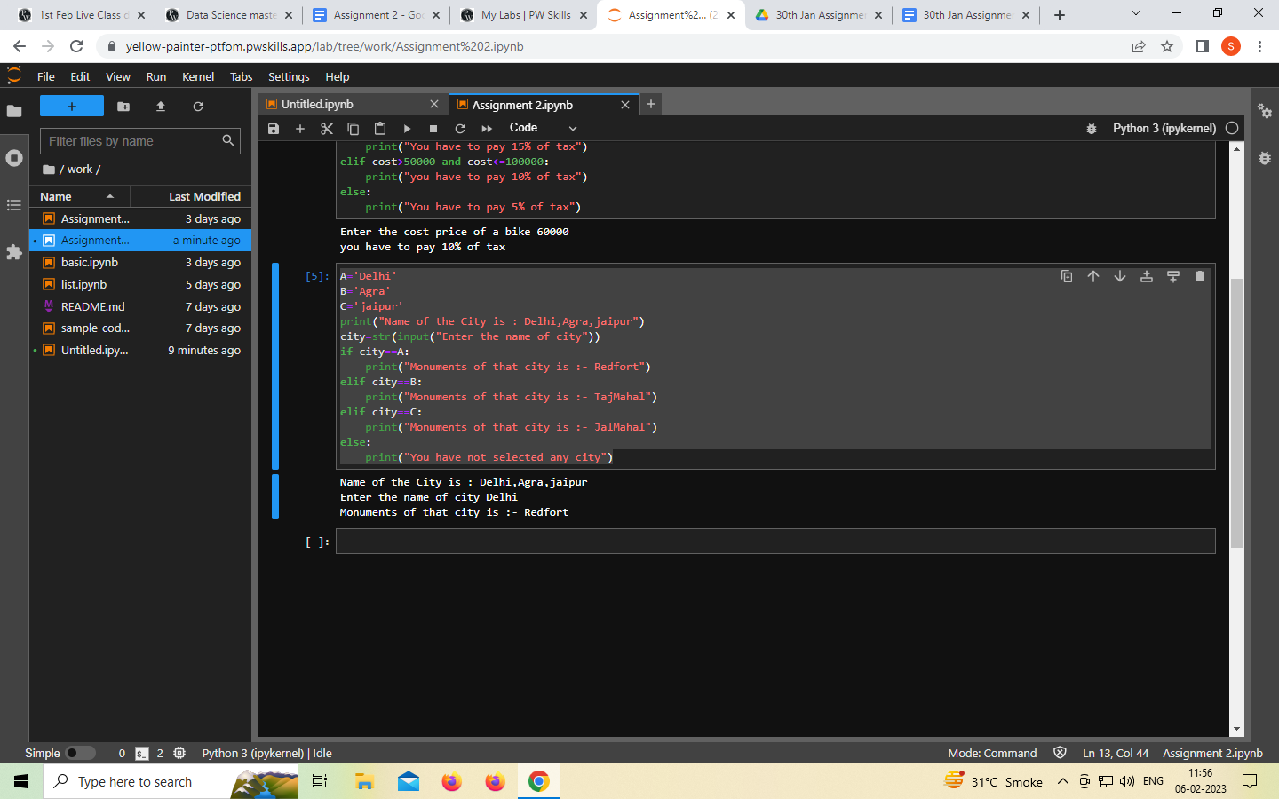

4 . Check how many times a given number can be divided **by** 3 before it is less than or equal to 10.

Code:

number=int(input("Enter a number"))

count=0

while number>10:

number=number/3

count+=1

print("The number of times the number can be divided by 3 before it is less than or equal to 10:", int(number))

output:

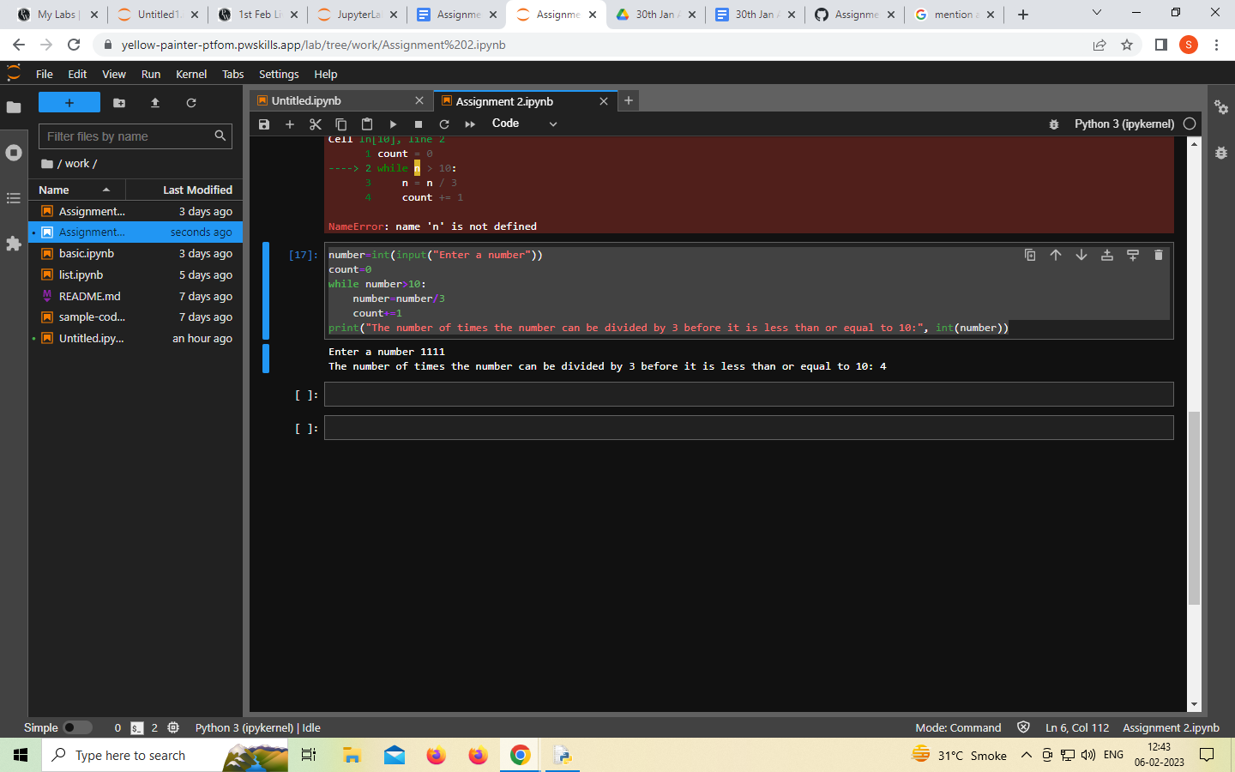

5. Why and When to Use while Loop **in Python give** a detailed description with example

ANS:

**While Loop** is used to execute a block of statements repeatedly until a given condition is satisfied. And when the condition becomes false, the line immediately after the loop in the program is executed.

count = 0

while (count < 3):

count = count + 1

print("Hello Geek")

6 Use nested while loop to **print 3** different pattern.

Code: 1)

i=1

while i<=5:

j=1

while j<=i:

print(j,end=" ")

j=j+1

print("")

i=i+1

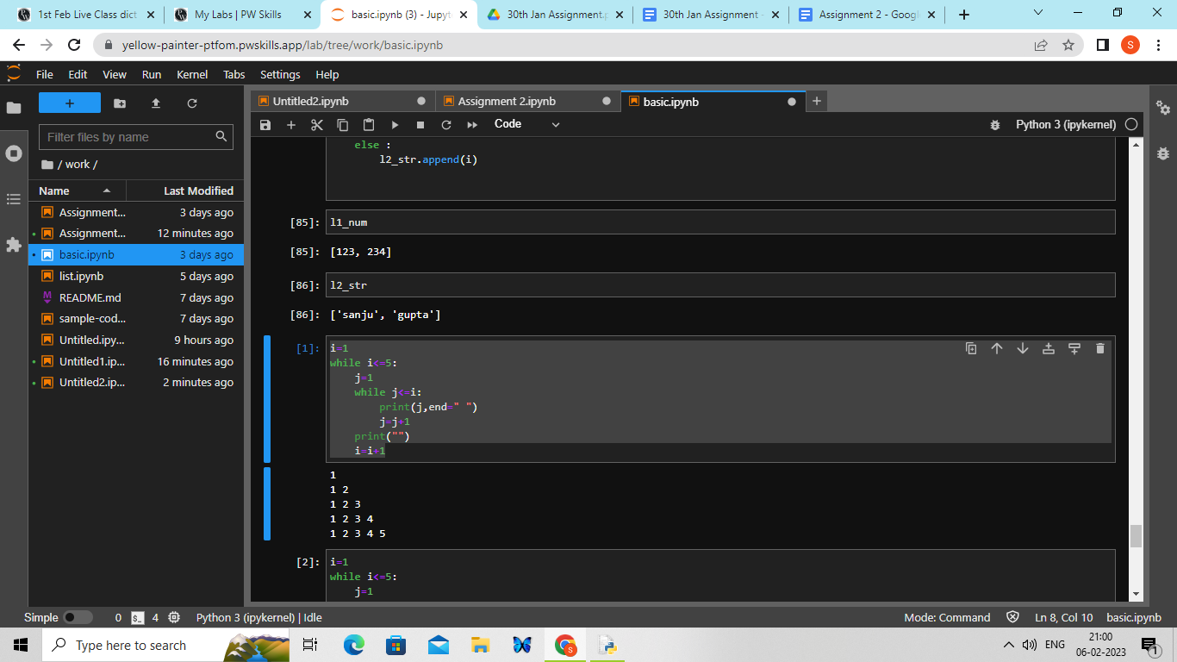

2) i=1

while i<=5:

j=1

while j<=i:

print(i,end=" ")

j=j+1

print("")

i=i+1

Output:

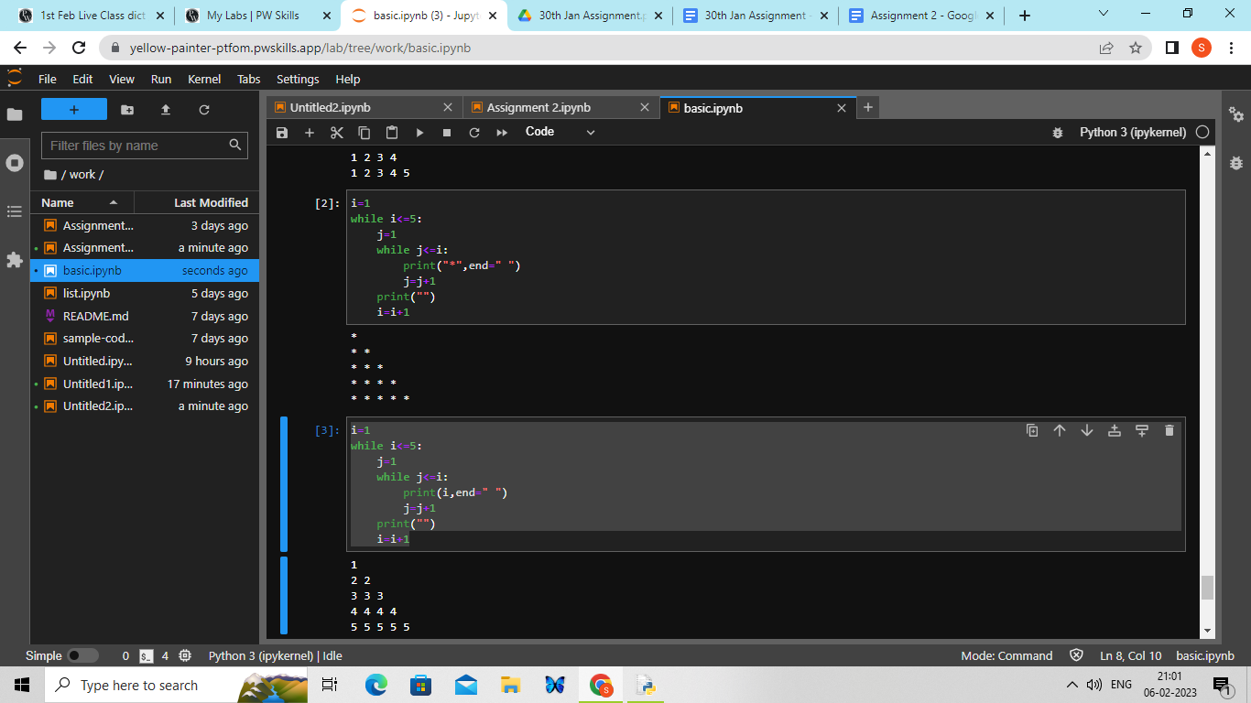

3)

i=1

while i<=5:

j=1

while j<=i:

print(i,end=" ")

j=j+1

print("")

i=i+1

Output:

i=1

while i<=5:

j=1

while j<=i:

print(i,end=" ")

j=j+1

print("")

i=i+1

Output:

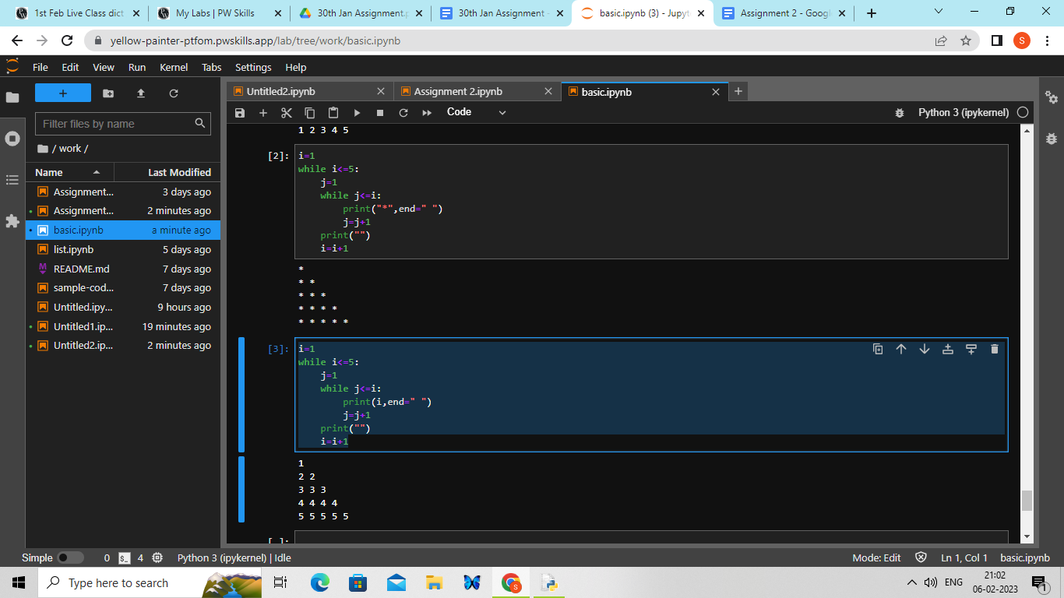

**7).** Reverse a while loop to **display** numbers from 10 to 1.

Code: i = 10

while i > 0:

print(i,end=" ")

i = i - 1

Output:

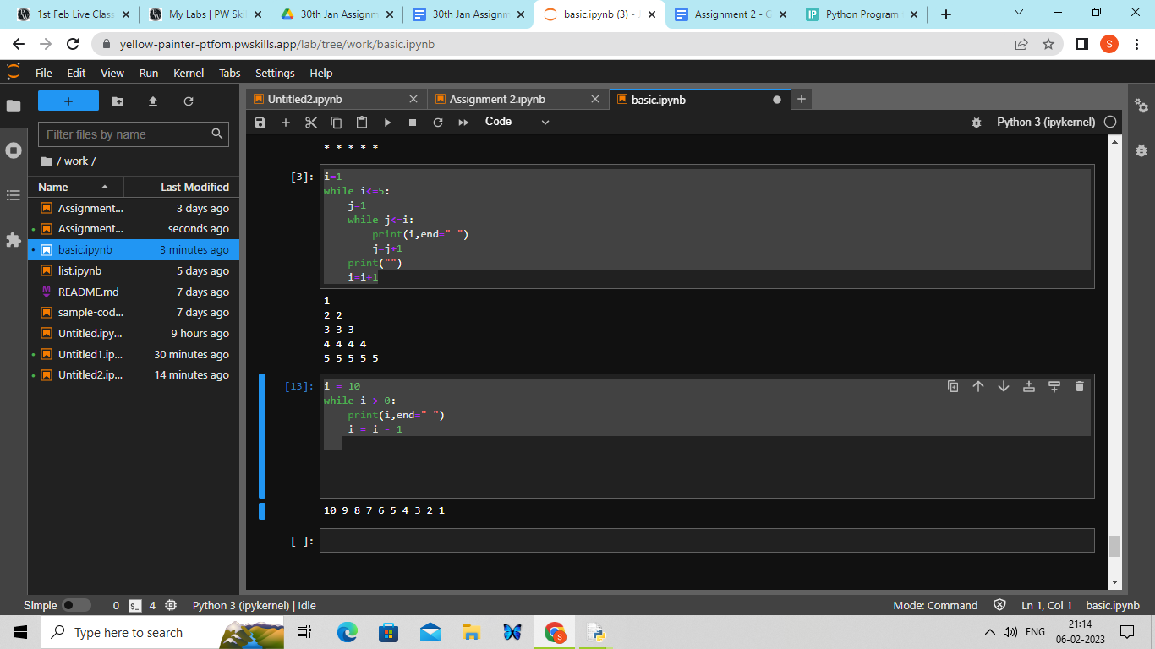

**8).** Reverse a while loop to **display** numbers from 10 to 1.

Code: i = 10

while i > 0:

print(i,end=" ")

i = i - 1

Output:

